**CANDIDATES NAME:…………………………………………………………………**

|  |  |  |  |  |  |  |  |
| --- | --- | --- | --- | --- | --- | --- | --- |
| **INDEX NUMBER** | | | | | | | |
|  |  |  |  |  |  |  |  |

**SIGNATURE: ……………………………………**

**273/2**

**GEOGRAPHY**

**PAPER 2**

**JUNE/JULY**

**2 HOURS 30 MINUTES**

**MOCK EXAMINATIONS SET 1 2019**

**Uganda Certificate of Education**

**GEOGRAPHY**

**PAPER 2**

2 HOURS 30 MINUTES

**INSTRUCTIONS TO CANDIDATE:**

* *Answer four questions only.*
* *Choose two questions from part I and two from part II.*
* *Any additional question(s) answered will not be marked.*

**PART I: THE REST OF AFRICA**

**(Answer only two questions from this part)**

1. a) Draw a sketch map of Africa and on it mark and name:

i) Lakes: Tanganyika, Tana and Volta

ii) Rivers: Zambezi and Orange

iii) Seas: Red and Mediterranean (8 marks)

b) Describe the processes that led to the formation of Lake Tanganyika.

(5 marks)

c) Explain the value of drainage to the people of Africa. (8 marks)

d) Outline the problems faced by people living around the drainage features of Africa. (4 marks)

2. Study figure 1 of the Volta multi – purpose river development project and answer the questions that follow.

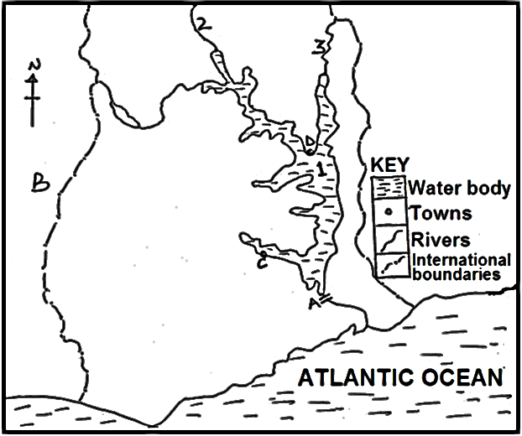

a) Name the:

i) dam marked A

ii) country marked B.

iii) towns marked C and D.

iv) water bodies marked 1, 2, and 3. (7 marks)

b) Outline the aims of the Volta multi – purpose river development project.

(4 marks)

c) Explain the importance of the Volta multi – purpose river development project. (6 marks)

d) Outline the:

i) Problems resulting from the Volta multi – purpose river development project. (5 marks)

ii) Steps being taken to solve the problems in d (i) above. (3 marks)

3. Study table 1 below, showing Southern Africa Development Corporation (SADC) mine production of selected major minerals, 2011 and answer the questions that follow.

|  |  |
| --- | --- |
| Mineral | Production (‘000 tonnes) |
| Coal  Copper  Gold  Zinc  Platinum | 256,755  1,371  68  238  158,400 |
| Total | 416,833 |

**Adopted: Department of mineral resources directorate mineral economics World Bureau of metal statistics Pg. 36.**

a) Draw a bar graph to represent the information contained in the table above. (7 marks)

b) Identify the mineral which is produced in;

- smallest

- largest (2 marks)

quantities in SADC.

c) Giving specific examples, describe the conditions which have favoured mineral production in any one SADC country. (8 marks)

d) Outline the:

i) Problems facing the mining sector, (6 marks)

ii) steps being taken to improve the mining sector (3 marks)

in SADC countries.

4. a) Draw a sketch map of Egypt and on it, mark and name:

i) Industrial towns: Cairo and Alexandria

ii) River Nile

iii) Aswan high Dam

iv) The Suez Canal

v) Neighbouring countries: Libya and Sudan. (8 marks)

b) Identify any three types of industries found in any one industrial centre named in a(i) above. (2 marks)

c) Describe the factors which have influenced the development of industries in Egypt. (8 marks)

d) Explain the effects of industries on the physical environment in Egypt.

(6 marks)

**PART II: STUDIES IN DEVELOPMENT**

**(Answer any two questions from this part)**

**REGION I: NORTH AMERICA**

5. a) i) Mention any two forested highlands in British Columbia. (2 marks)

ii) Describe the characteristics of tree species in any one forested highland mentioned in a(i) above (6 marks) b) Describe the physical conditions favouring tree growth in British Columbia.

(8 marks)

c) Explain the problems faced by the forestry sector in British Columbia.

(6 marks)

d) Name any three tree products exported by British Columbia. (3 marks)

6. Study figure II: the sketch map of the South and answer the questions that follow.

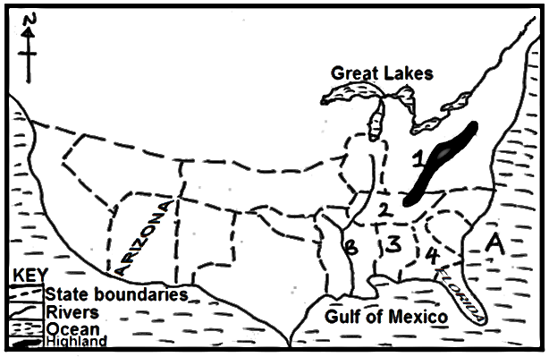

a) Name the:

i) water body marked A and B.

ii) mountain range marked 1.

iii) states marked 2, 3 and 4. (6 marks)

b) Describe the conditions that led to severe soil erosion in any one state identified in (a) (iii) above. (6 marks)

c) Explain the steps that were taken to control soil erosion in the South.

(8 marks)

d) Outline the negative effects of the developments in the Tennessee valley area on the environment. (5 marks)

7. a) Draw a sketch map of California and on it mark and name:

i) Towns: Los Angeles and Sacramento

ii) Pacific ocean

iii) Rivers: Sacramento and San Joaquin

iv) All American canal. (7 marks)

b) Outline the characteristics of market gardening in California. (5 marks)

c) Explain the benefits of market gardening in California. (6 marks)

d) i) Outline the problems caused by market gardening on the environment in California. (5 marks)

ii) Identify the two major irrigated market gardening areas in California. (2 marks)

**REGION II:**

**RHINELANDS**

8. Study figure III: map of Switzerland provided below and answer the questions that follow.

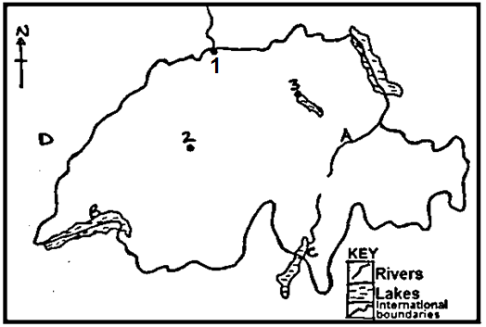

a) Name the:

i) towns marked 1, 2 and 3

ii) river marked A.

iii) lakes marked B and C.

iv) country marked D. (7 marks)

b) Describe the conditions that have favoured the development of any one town in a(i) above. (8 marks)

c) Explain the functions of the town chosen in (b) above. (6 marks)

d) Outline the problems facing urban centres in Switzerland. (4 marks)

9. Study the table 2 below showing the land use types in the Netherlands and answer the questions that follow.

|  |  |
| --- | --- |
| Land use type | Total land use (ha) |
| Arable farming  Horticulture  Permanent pastures  Wood land and wasteland  Others | 770,000  140,000  1,505,000  252,000  560,000 |
| Total | 3,500,000 |

a) Draw a pie chart to show the relative importance of land use types in the Netherlands. (8 marks)

b) Identify the:

i) major

ii) least

land use type in the Netherlands. (2 marks)

c) Describe the factors which have favoured any one land use shown in the table above. (6 marks)

d) Explain the importance of land use types in the Netherlands. (6 marks)

e) Outline the challenges facing land use in the Netherlands. (3 marks)

10. a) Draw a sketch map of Belgium and on it mark and name:

i) Coal fields: Liege and Charleroi

ii) Towns: Brussels and Antwerp

iii) Rivers: Meuse and Scheldt (8 marks)

b) Describe the conditions that have favoured coal mining in Belgium.

(6 marks)

c) Explain the benefits of mining to the development of Belgium. (6 marks)

d) Outline the effects of mining on the environment in Belgium. (5 marks)

**END**